***Programming in C++ with Lab*  
Group Project - Journal**

**Team Name: Code Busters**

**Journal Link:** [**https://docs.google.com/document/d/1_kFjrJh8IWxcOGEV-ClOHiJztGhrmoITypqcSr_Le6U/edit?usp=sharing**](https://docs.google.com/document/d/1_kFjrJh8IWxcOGEV-ClOHiJztGhrmoITypqcSr_Le6U/edit?usp=sharing)

**Team Members: Varsha Gunturu, Vineesha Vuppala, Karmandeep Singh, Sindhu Vankadaari, Laya Lakshminarayanan, Sneh Pahuja**

**Project Topic: Photo Editing Application EBODA**

**Requirements:**

Please refer to this for detailed guidelines - [CSIT211 Project Journaling Guidelines](https://docs.google.com/document/d/1PWA8GKd8dyMRBgXzE2wvbwQ--n01bQtnybxNL6_qzlI/edit?usp=sharing)

**Group journal:**

**Group meeting 1-**

**Meeting date and time: 18th November || 7:15 to 8:15 pm**

We planned the flow of our application over an online meeting. The below information is the notes that we took during the meeting. We brainstormed and wrote down how to go about the project.

Main

Home page file

* Greeting
* Links to other functions

- About Page

- Help Page

- Editing

About Page file

* Text and images

Help Page file

* Different sections - features

- tutorials/images

* Commonly Asked questions

Editing file

- Links

- Import Function

- Brightness functions

- Tools functions

- Sharing function

- Comparison function

- Undo function

We also divided research and work for different functions.

Functions for different people

Black and White - Varsha

Grayscale tool - find the weighted or simple average of rgb values - apply it to all pixels

Brightness Tool - value between 0 and 255 to increase image by a certain brightness increase each colour by that value

Cropping Tool - Varsha

Rotating Tool- Sindhu

Reflection Tool

Blurring entire or background Tool- Sindhu

Saturation Tool- Karmandeep

Highlights Tool/ Shadows tool

Contrast Tool

Temperature/ Tint Tool

Clarity Tool-Karmandeep 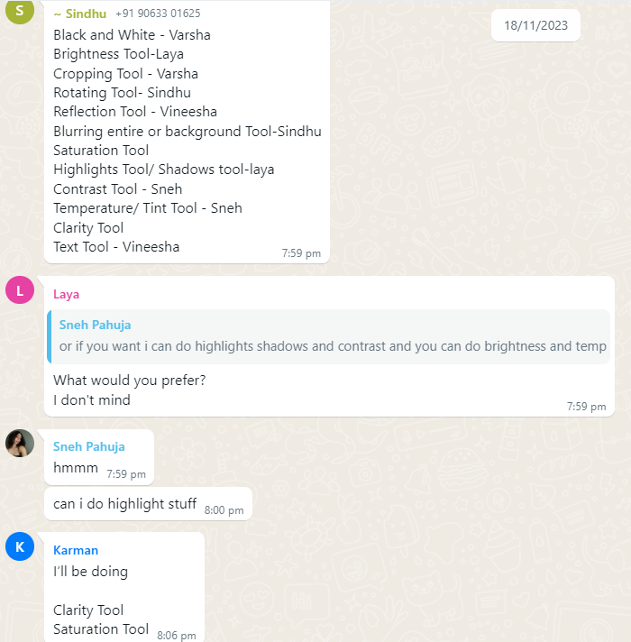

Text Tool

1 or 2 Coloured Filter

Over WhatsApp we decided which tools we each wanted to work on (image on the left)

**Group chat discussions-**

**Date: 21st November**

During these discussions we talked about the research we did and what we found about the various tools and installing opencv. We looked at the project done by Vineesha’s friend to see what she had done and what process we can follow. 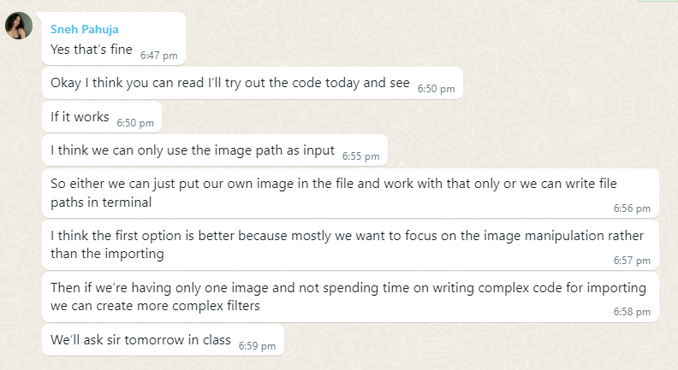

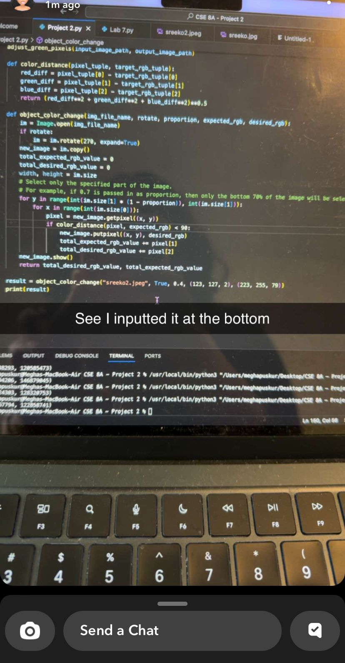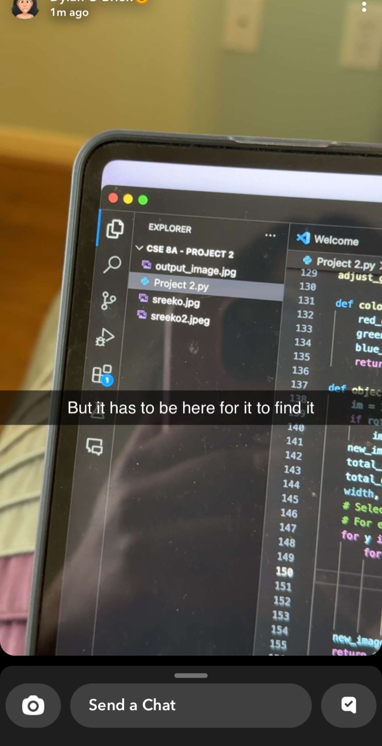

These were the codes that her friend shared (images above)

**Dates: 22nd and 23rd November**

Again on Whatsapp, we shared the research we found amongst ourselves so we could all explore. Sneh and Varsha shared youtube and article links that would help out. We also talked about the challenges we were facing with vs code and opencv. We looked into downloading the compiler on vs code

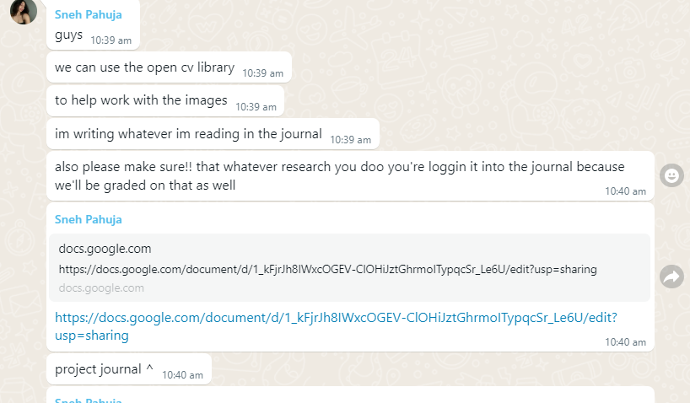

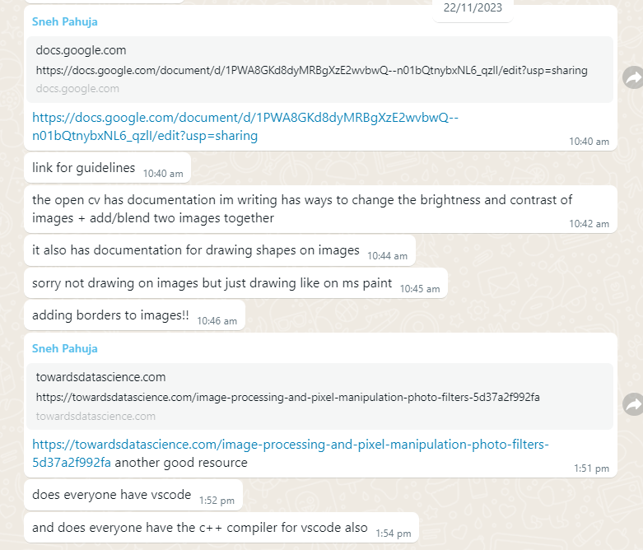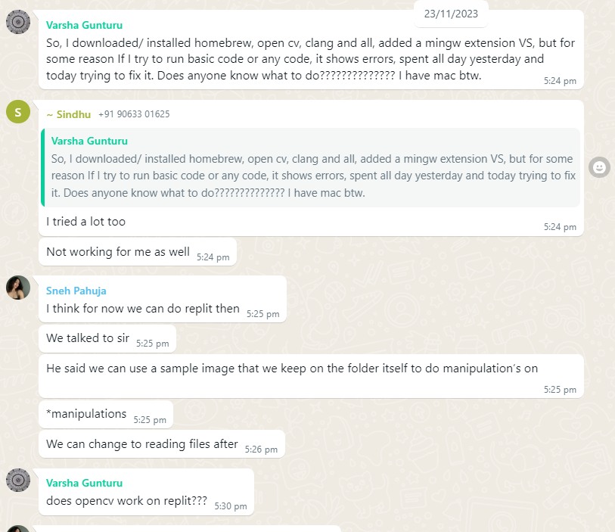

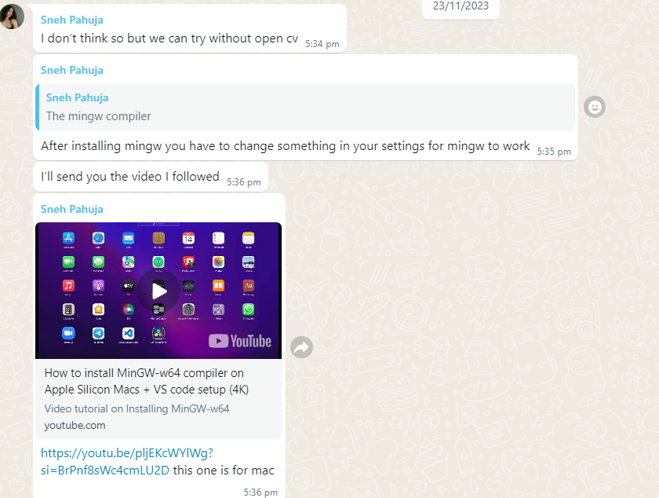

Links:

1. <https://towardsdatascience.com/image-processing-and-pixel-manipulation-photo-filters-5d37a2f992fa>
2. <https://www.youtube.com/watch?si=BrPnf8sWc4cmLU2D&v=pljEKcWYlWg&feature=youtu.be>

**Group meeting 2-**

**Meeting date and time: 27th November || 9 - 10:30 pm**

This day most of us met up at the library to discuss about our progress. Varsha told us about how she got opencv to work and the process she went through. After this, we all updated each other on our progress and challenges. We helped each other out at this meeting. We also decided that we would all separately work on our codes and provide the final one to Varsha because she was the only one that had opencv working on her laptop. During the meeting, we all tried to look into various youtube videos to get opencv to work on our laptops. But since it did not, we decided to use Varsha’s laptop.

Links-

1. <https://www.youtube.com/watch?si=e8Z1AfCFHa8_E8VA&v=dgYy4Cf1qO4&feature=youtu.be>
2. <https://www.youtube.com/watch?v=IaMI4t-dvHY>

**Meeting date and time: 30th November || 6 to 7:30 pm**

This day Varsha, Vineesha and Sneh met to work on their codes together. They combined the codes to check if they worked. Karman had sent his codes before so that was also combined to see if it worked with opencv.

After this, we did not have any further group meetings. We worked individually and collaborated with Varsha when we were done. Laya worked on the presentation that was on 2nd December since she was not going to be there.

Link - <https://www.canva.com/design/DAF1tqaZFN0/5oe54RzNHPHyDQJkDu02XQ/edit?utm_content=DAF1tqaZFN0&utm_campaign=designshare&utm_medium=link2&utm_source=sharebutton>

**Group discussion-**

**Date: 7th December**

We made some final changes to the code by adding user friendly interface to introduce the application

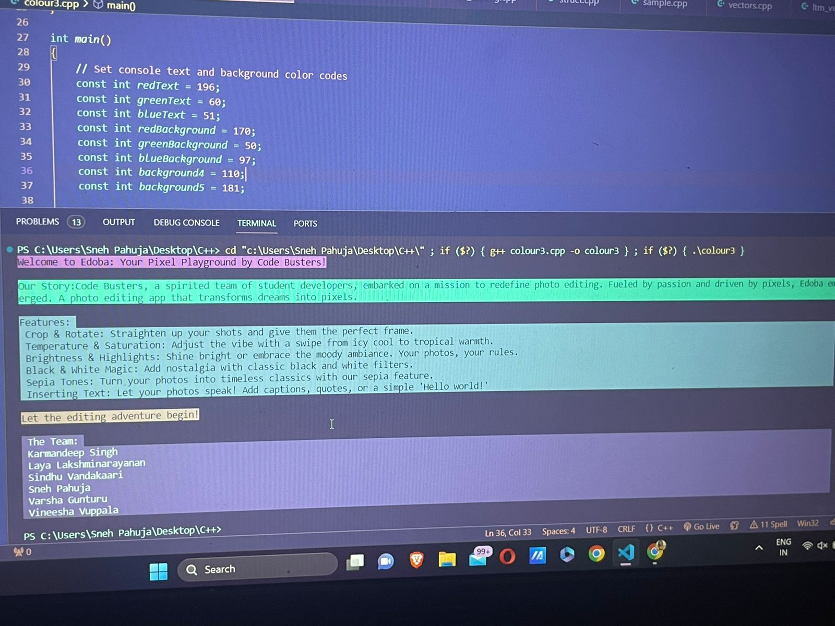

**Individual journal:**

## Sneh Pahuja

**Date: 22nd November || 10:15 a.m**

Google Search

*Search Prompt 1:* Image libraries C++

*Search Prompt 2:* Open CV c++

Found this link for documentation on Open CV

<https://docs.opencv.org/4.x/d9/df8/tutorial_root.html>

I read through the following:

* Operations with images - https://docs.opencv.org/4.x/d5/d98/tutorial_mat_operations.html
* Adding (blending) two images using OpenCV - <https://docs.opencv.org/4.x/d5/dc4/tutorial_adding_images.html>
* Changing the brightness and contrast of an image! - <https://docs.opencv.org/4.x/d3/dc1/tutorial_basic_linear_transform.html>
* Discrete Fourier Transform - <https://docs.opencv.org/4.x/d8/d01/tutorial_discrete_fourier_transform.html>
* Basic Drawing - <https://docs.opencv.org/4.x/d3/d96/tutorial_basic_geometric_drawing.html>
* Adding Borders to images -

<https://docs.opencv.org/4.x/dc/da3/tutorial_copyMakeBorder.html>

* Make your own linear filters! -

<https://docs.opencv.org/4.x/d4/dbd/tutorial_filter_2d.html>

* Smoothing images -

https://docs.opencv.org/4.x/dc/dd3/tutorial_gausian_median_blur_bilateral_filter.html

* Finding contours in images -

https://docs.opencv.org/4.x/df/d0d/tutorial_find_contours.html

* Out-of-focus Deblur filter -

https://docs.opencv.org/4.x/de/d3c/tutorial_out_of_focus_deblur_filter.html

* Periodic Noise Removing filter -

<https://docs.opencv.org/4.x/d2/d0b/tutorial_periodic_noise_removing_filter.html>

*Search Prompt 3:* how to use opencv in vscode c++

Found this link with an explanation

<https://medium.com/analytics-vidhya/vs-code-with-opencv-c-on-windows-10-explained-256418442c52>

<https://www.opencv-srf.com/2017/11/install-opencv-with-visual-studio.html>

<https://www.opencv-srf.com/2017/11/opencv-cpp-api.html>

Looked at old code I had partially written for a similar program

<https://github.com/code50/100990737/blob/main/filter-less/helpers.c>

<https://github.com/code50/100990737/blob/main/filter-less/filter.c>

End time: 11 a.m 22nd November

**Date: 22nd November || 1:45 p.m**

*Search Prompt 1:* how to increase saturation of images pixel manipulation

https://towardsdatascience.com/image-processing-and-pixel-manipulation-photo-filters-5d37a2f992fa

* A contrast value of 0 means that all pixels have the same brightness value. A contrast value of 1 means that the difference between the highest brightness and lowest brightness is 255 (maximum difference).

End time: 2:00 p.m

**Date: 29th November || 7:00 p.m**

Trying to download opencv and setting it up

https://www.youtube.com/watch?v=m9HBM1m_EMU

**Date: 30th November || 12:00 a.m**

Despite trying for 5 hours, I was having difficulty setting up the opencv. I watched youtube tutorials and tried asking chatgpt but there were always issues of permission being denied for opencv due to which it was not configuring properly. I then asked Varsha, since she had already managed to download opencv on her laptop and configure it properly, if I could send her my code and she could integrate it.

<https://chat.openai.com/share/89ef4d05-c099-453a-8add-4c47a4679d1a>

**Date: 30th November || 11:00 a.m**

I sourced the code for adjusting the temperature of an image through Chatgpt and then sent it to Varsha. She said it worked but only for making the picture warmer (positive temperature) not for making it “cooler”(negative temperature). This is because in the first code, the blue channel was always being adjusted to make the picture warmer. A small change from subtracting to adding to the blue channel helped solve the issue.

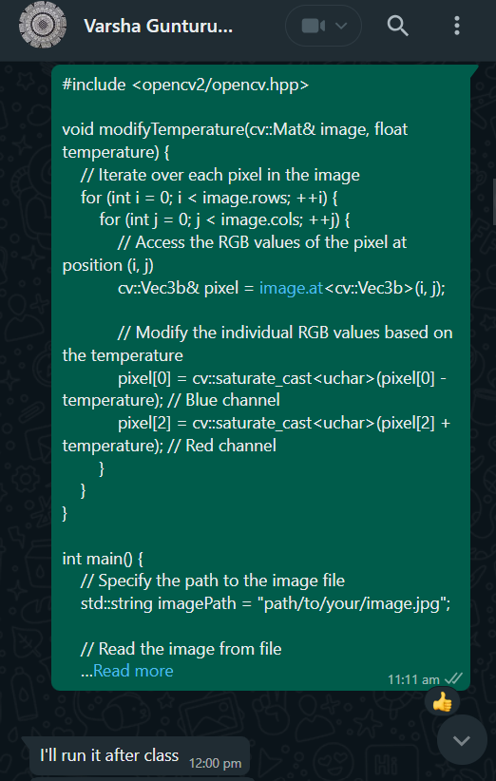

[**https://chat.openai.com/share/2605fb8e-b563-4f9a-b8f4-4eaceb2372a1**](https://chat.openai.com/share/2605fb8e-b563-4f9a-b8f4-4eaceb2372a1)

**Date: 1st December || 5:30 p.m**

I sent Varsha the brightness tool as well. This was way easier to source, as changing the brightness only requires multiplying each pixel’s intensity value by an alpha provided by the user (above 1 for increasing brightness and below 1 for decreasing brightness).

<https://chat.openai.com/share/274c650e-db2c-4c2c-a109-00361d54d7aa>

I also wanted to incorporate the previous code I had written for another course in C. The filter was a box blur. I used Chatgpt to rewrite it in C++ and incorporate it with opencv. However, there was an issue, as the function directly used a 2 dimensional array of pixels,as an argument but the width and height were not made constant and thus, it could not work, unless we kept the application for only images with the same height and width.

<https://chat.openai.com/share/ed7f0f16-7750-49c8-9cc8-2a1a75960e44>

**Date: 8th December || 3:30 p.m**

I sourced a sepia filter for the application, but it had the same effect of having a higher temperature, so we decided to leave it out of the code.

<https://chat.openai.com/share/05c0885c-28f2-46fd-96e4-9cd36412d441>

I also wanted to create a homepage for the application. I wanted to see if it was possible to get coloured boxes on the vscode terminal.

<https://chat.openai.com/share/9ea39781-ed0b-44d1-9859-4e975e2db60f>

After a couple of tries as well as tinkering with the output colours, I got the result I wanted.

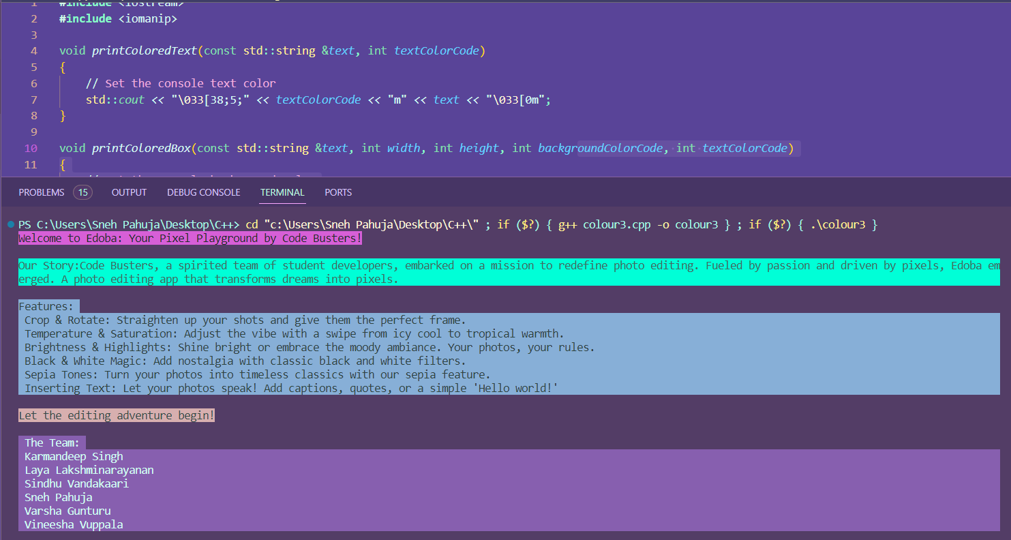

I sent the code to Varsha, however, on her laptop, the colours did not show up.

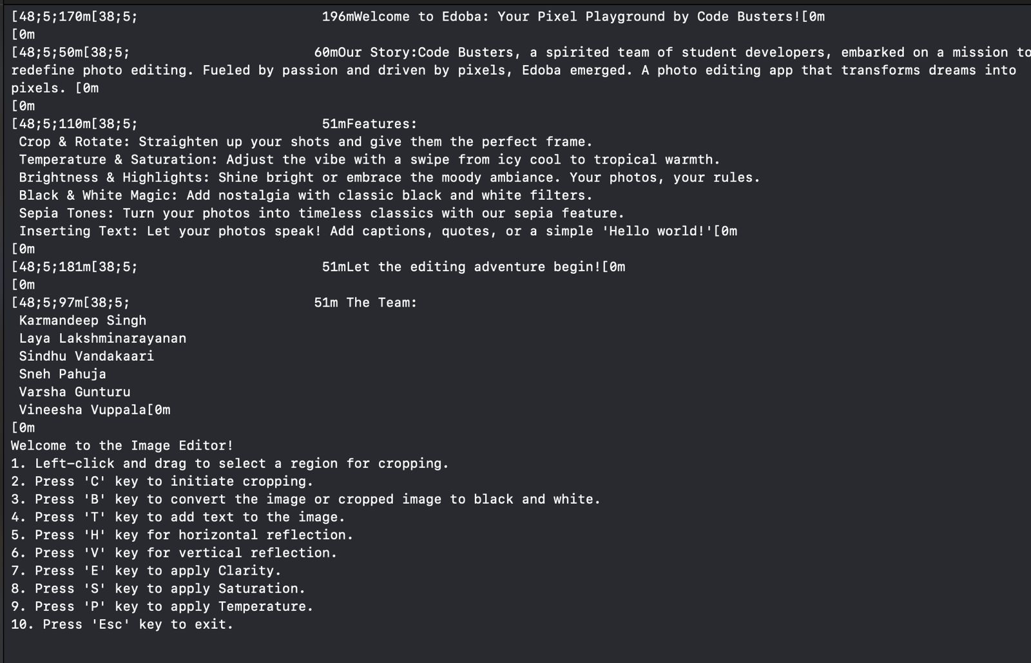

So we decided to keep the homepage simple, without any colours :(.

**Final Thoughts**

I think the assignment helped me learn how to leverage AI tools, rather than just thinking that they will solve things for me easily. I also learnt that especially when using AI, error checking is crucial. Also, AI can be useful if you’ve already written code in one language and you want to rewrite it in another but don’t want the hassle of retyping the entire code. It was a fun experience, getting to see pictures transformed, as a result of what you have created.

______________________________________________________________________

## Karmandeep Singh

**Date: 22nd November || 9:00 pm**

Search Prompt-1 (ChatGPT):What are the OpenCV Libraries in C++?

<https://chat.openai.com/share/75ccdca6-a8b0-4463-884f-07dca0b03743>

* Learnt about OpenCV
* An open source library with multiple tools and functions for working with Images and Videos

Search Prompt-2 (Google): Clarity and Saturation Tools implementation in c++

>Could not find anything exactly what I was looking for, however I got somewhere close to it, so read up an article on G4G.

<https://www.geeksforgeeks.org/image-enhancement-techniques-using-opencv-python/>

Read a few articles on Stack Overflow and learnt about transforming saturation and lightness values of each pixel.

<https://stackoverflow.com/questions/47973697/c-adjust-hsl-of-an-image-without-clipping>

Search Prompt-4 (ChatGPT): Ask ChatGPT to give me a sample code of how a tool such as Saturation functions with explanations and gain a bit more clarity conceptually.

<https://chat.openai.com/share/75ccdca6-a8b0-4463-884f-07dca0b03743>

* Understanding the process and flow from uploading an image onto the application, converting its format to HSV and splitting it before actually tempering with the pixels and technicals.

**Date 24th November || 7:30 pm**

(X) Mistake Made: I directly jumped to figuring out the source code for the Saturation and Clarity Tools as you can see from my 22nd November Journal. This was a HUGE mistake as I thought I had learnt enough about OpenCV and I can get to work now. Therefore I had to head back to basics. I directly got to work after my CS class.

Since I am a CS minor, I do not possess the additional knowledge that my fellow classmates do, so I wanted to be a bit more clear with what I am working on and what I am working with. Straightway, I got to YouTube and ChatGPT to get my basics right.

1. Here is the list of YouTube videos I watched to understand what is OpenCV. As I am running VSCode on my laptop, I thought lets try and get it running up there as well.

* <https://www.youtube.com/watch?v=_aBFA4g8l8E>
* <https://www.youtube.com/watch?v=xAPB3EWmeew>
* <https://www.youtube.com/watch?v=m9HBM1m_EMU>

1. Here are my ChatGPT prompts that I used to learn the same. This time around, I used what I learnt from the AI-Activity we had done in the class twice, and applied what I had learnt by giving ChatGPT a more refined prompt with context. This allows artificial intelligence to give me a more accurate response to what I need!

ChatGPT: <https://chat.openai.com/share/ca1a4c8a-f2ba-4685-92a4-224a7ea80847>

* Incase ChatGPT Link does not work, here is the prompt I gave
* *“I am building an app for my C++ Course in University. I am a Computer Science Minor. I am building a Photo Editing Application, which allows the user to use tools such as Saturation Tool and Clarity Tool. Teach me in a simple way about OpenCV. Next, tell me about the code for these two tools, giving me bullet points as to how its functioning”*

Bard AI: <https://g.co/bard/share/6d2b4844f8b6>

**Date: 27th November || 9:15-11:30PM**

**(X) Group Meeting Day**

(X) Installation of OpenCV on VSCode needed to be done.

* Googled it.

YouTube Video referred: <https://www.youtube.com/watch?v=Ozc3zWJ_NhQ>

* Had errors downloading these files.
* Took help from a prompt generated by teammate Varsha
* Main issue is getting it up and running on Mac Devices. Since different mac devices have different compilers and pre-installed softwares, one method does not fit all.

(X) Test running the code for Clarity and Saturation Functions on Xcode with OpenCV installed.

* Couldn't get OpenCV to install on my Mac. I sent the code to teammate Varsha who has a fully functional Xcode with all OpenCV Files.
* Initial test code built successfully and runs properly.
* Clarity and Saturation tools were not running in an isolated file.
* Showed an error on XCode, then prompted ChatGPT to refine the code for it to run smoothly on Xcode.
* There was an error combining the functions on the terminal.

Link: <https://chat.openai.com/share/c747b42d-2938-4967-8248-1740b1067318>

* Tried running the new codes on Xcode, still was not building correctly.
* Ask GPT again to define the functions separately in order for them to open separate windows for separate functions.
* Main error was in calling the functions.
* Features are running but still need some polishing.

Learning: Even though for now, it was not running on my mac, moving forward, I need to get this sorted because this was just a group project.There might come a time I may need to implement OpenCV once again, but this time by myself. I will ask my fellow peers in the classroom with macs, and ask for assistance as to how I can get it to run.

**Date: 28th November || 8:00 pm**

Since the presentation was due in a few days, I had to start preparing for it. Simply showing the tools will not be enough, therefore I needed extra background knowledge to show my peers what's happening behind the scenes of my tools and in the code in the general

I headed over to ChatGPT to get the inputs:

(ChatGPT link was not working, therefore I am putting the prompts I put up and some of what I learnt)

* “For the above code you gave me for the Saturation Tool and Clarity, in simple bullet points explain with some details what is happening, how is the code running and what kind of classes have been implemented in them”
* “Okay, now tell me about the potential errors I might face with the code above”

=> I learnt about how the “imshow” function was being used to showcase the image we chose into the terminal. I saw how the parameters of this function were executed. This was very similar to something we had done in class, it was the FLAME BANKING APPLICATION. For the Deposit and Withdraw functions, we took similar parameters which were based on the Original Amount, and then the Deposited Amt. and Withdraw Amt. I immediately link this back to the code. To double check, I opened the Replit I had done this on, and I was Spot On. In principle the same parameters.

=> Next, I learnt about the “mat&” class which was being used in our code. This is a class in Object Oriented Programming, and it stands for MATRIX. It is used to store and manipulate the pixel value of the image. Think of the image being turned into a cross sectional matrix, at every intersection, it stores as a pixel value. This allowed me to make sense of what was happening to the image, and gave me a clear picture of how it manipulates the image.

**Date: 1st December || 11:00 pm**

As the presentation was due the next day, to be safe I prompted ChatGPT to summarize all that I had done up until now in a way its doable for a presentation.

ChatGPT prompt:

* *“I have to do a presentation for the above code you have taught me, I want you to summarize all the key details and points about all the prompts and answers above, and present them to me in simple bullet points, that I can present during the presentation”*

=>This directly gave me 24 bullet points and summarized the entire process from start to finish.

**Final Thoughts for this Project -**

Overall, this project was a good learning experience for me. I am a very hands-on approach person, and this project allowed me to do exactly that. Even though I did not generate the entire code myself, I was able to make sense of what is going on, and how the function is taking the parameters based on what I have learnt in class. Before we began, I will not lie, I was slightly intimidated about how Ill get this project done. I was not sure if I'll be able to make sense of what is happening. Even though using AI is one thing, I wish to connect the dots and link what I learned in the class to what I am doing here. Thankfully I was able to do, more than what I expected. I think I just overestimated this entire project.

The team members I worked with, I have not previously worked with, and therefore was an opportunity to work with them collaboratively. All the group meetings went smoothly, and our discussions were to the point. We did not allow ourselves to be distracted, and made use of every minute of the meeting as we all also had other course projects to tend do. A big thanks to our group member Varsha Gunturu for compiling all our codes, and giving us feedback about how we could improve our programs for a refined result. She took the extra effort to compile and find our errors. Also thank you to another member Sneh Pahuja for designing the main page, and doing the final touches for our submission!

A key point is the use of ChatGPT and AI tools. Yes, I relied very heavily on ChatGPT, but I feel I used it to my advantage by asking it to teach me the concepts in a simple way as I progressed along this journey. I will not lie, I was not expecting to write the Saturation and Clarity tool myself considering my dearth of experience and knowledge. However, I learnt along the way the details and what goes behind the scenes of the code. Another main learning was that I I also learnt how to give better prompt to ChatGPT. Through trial and error, and multiple iterations of asking it to give me codes and solve my doubts, I learnt that the prompt can be more detailed to get a more detailed answer from it.

Only obstacle (that I am yet to overcome) was running OpenCV on my mac through VS Code. I know there has to be a way to overcome this, and will spend some time when I am free(examinations are coming up) and ensure it runs smoothly!

Overall, a good learning experience.

Thank You Prajish Sir for being an amazing mentor and clearing doubts when needed.

CSIT211: Programming in C++ with Lab.

____________________________________________________________________________

## Varsha Gunturu

**Date: 23rd November Time: 3:15pm-8:00pm**

Tried Installing homebrew and opencv, clang, Found errors in compiler path then include path. Trying to get it fixed so that Opencv can run on the Mac laptop in Visual Studio. VS couldn’t find the header files for c++, this caused a lot of problems, which I spent 3 days on. I tried uninstalling and reinstalling VS code, which still did not fix the error. I tried finding c++ header files and adding them directly into the folder I was working on. I couldn’t find the header files so I decided to install them or the compiler on the terminal and updated the required compiler on the terminal. Then tried linking c++ with opencv on the terminal with cmake. I tried updating the tools. Still the error couldn't be figured out.

All Youtube video references for setting up opencv on xcode when visual studio wasn’t working and VS showed error on include line as it couldn’t find the header file:

<https://youtu.be/BDYQ1tBcl3E?si=MtX_vOl2ddMC-PiE>

<https://youtu.be/m9HBM1m_EMU?si=H5htW14ctSNFeGz7>

<https://youtu.be/dgYy4Cf1qO4?si=oR7qaVdmZNkgYtz1>

<https://youtu.be/LmSCoiCHouc?si=SdpOOO7UV-dHut6g>

<https://youtu.be/o62iO8SssZk?si=La0v5y3Q15wWuDJp>

<https://youtu.be/DnQoPaYGFzw?si=xdyqdHZMDjq9-_SE>

<https://youtu.be/q_WWGIbFgfQ?si=wW4VP2PgkroJFBnY>

<https://youtu.be/-H_EyIqBNDA?si=8fN5_ksGV_Kad4a->

<https://youtu.be/fz2gDUO6XkM?si=l29waIAHvlRHBdCG>

<https://youtu.be/5dZFvlxFx38?si=8W-yOgAmqoaYpjCA>

<https://youtu.be/9gV7Mc-GteM?si=GqDbd6LiGDM2wX8f>

<https://youtu.be/9gV7Mc-GteM?si=SDcSUnzFi4FdDINv>

<https://youtu.be/yU0DyZovTHQ?si=mSoWe-WCxjBNkvPh>

<https://youtu.be/qkNuu3nHQz4?si=fhUyGn_1IazW-RwU>

<https://youtu.be/01ivxGVQF8g?si=OzIn6YSfEadDWVhk>

<https://youtu.be/hrPm7tWC-BI?si=JPRs49Ey7XE0kmRc>

<https://youtu.be/hrPm7tWC-BI?si=LM3fVM5qWTKVLC1e>

**Date: 24th November: Time: 7:00pm-8:40pm**

Used blackbox with the prompt : Write a c++ code that uses open cv to create a basic program that is taken in a picture as input from the user and lets the user use crop feature and black and white feature.

<https://www.blackbox.ai/share/29e37809-1bfd-408a-8865-fe2f33b02ee5>

<https://www.blackbox.ai/share/a3564bf7-038e-4da0-aad1-df9952b68208?userId=652d2de6d45e9d0031e777c2>

Tried understanding the code and the b=various keywords used there and tried to understand it, as to how the window opens with the image. What keywords were used for turning the image black and white or cropping. How the mouse arrow is used for cropping the image.

**Date: 25th November Time: 12:00pm-5pm**

After downloading xcode from AppStore, Tried running c++ programs on it. After the c++ program was running, I tried linking opencv to it. More errors were found as the opencv header file could not be found. Tried uninstalling and reinstalling open cv through homebrew.

Chat GPT prompt asked for solving this issue: how to install opencv, /usr/local/Cellar/opencv, why does this not work on my mac, how do i use opencv on xcode now, why can't i find my opencv at /usr/local/lib

Link: <https://chat.openai.com/share/fef85590-1c33-48bc-99f7-9fedea2d5552>

After all the tweaking in the terminal, I still couldn’t get the c++ running with opencv.

. Then went to xcode settings and changed the build settings to include opencv header files. Then also added some files from lib in opencv directly into the xcode folder to allow the program to run. The program successfully runs now. Created code with opencv that reads the path and opens the image in a window.

**Date: 26th November Time: 4:15pm-8:50pm**

Worked on the crop and black and white feature of the program. Used chatGPT to get a basic idea of the structure and build of the code necessary for performing these features.

Link: <https://chat.openai.com/share/6e75c241-5ff1-42ff-be5b-e648b324e010>

Found errors in the code and tried fixing them. Now both the cropping and black and white feature works.

**Date: 30th November Time: 6:00pm-8:00pm**

Got code from Group members Vineesha and karmadeep, helped them run the program on a laptop that had Opencv installed and running.

Tried Combining all their codes using chatgpt for errors

Link: <https://chat.openai.com/share/6e75c241-5ff1-42ff-be5b-e648b324e010>

Got the code that combined all their code and runs as a single program. Though it has some errors, I am trying to get the errors fixed.

**Date: 1st December Time: 5:36pm-6:30pm**

Got code from Sneh and ran it on my mac. Now combining Sneh’s code with the other’s code. Found some errors, where when the keyword t/T is pressed both the text and temperature functions were activated. Changed the keyword of temperature to P/p to keep the two features separate and not confuse the user.

**Date: 8th December Time: 4:03pm-5:50pm**

I received code from Sneh for a home page/welcome message. The code build succeeded but for some reason showed an error. Went through the code, reading line by line for the error. But there were no errors but the intended output was unable to be produced. The homepage was supposed to display the text in different colors on the terminal along with the text that introduced the code and the team members. So I had to remove the color and only include the text. Then I moved on to rotating the angle of the image sent by Sindhu.

**Date: 10th December Time: 2:50 pm-5:50pm**

Wrote the README file that included the required packages and some details on how the code runs with the small changes that needs to be made to be able to run on another laptop. Then worked on another code that Sneh sent me earlier that was the brightness tool, that I tried to work on using the blur of background of the image. Unfortunately the blurring the background feature didn’t work as expected and needed to change that to include only the brightness tool. Then created a separate folder with all the required documents and files for submitting.

**My understanding of the code-**

I downloaded the opencv package through homebrew and all the c++compilers and header files through xcode as vs wasn’t working. Then I asked blackbox for a sample code for the two features I was assigned by the group- cropping and black and white. I tried running that sample code on my laptop to see if it runs, and if I found any errors I fixed them with help from chatGPT which gave me the necessary information to see what went wrong and how to tackle it. Coming to the code, all the features such as cropping, black and white, adding text, etc were made into functions that were then called into the main function. We also globally declared some variables that were required. Then in the main function, we had a huge cout statement that showed all the features in this program and how they can be called through user input or keyword input to manipulate the image. We also had a statement that read the image that was stored in the laptop, and created a temporary window that displayed the image. Also added that the function is called only when the arrow/mouse is on the image window and the keyword is pressed. Then there is a while loop that runs until esc is pressed with the mouse on the image window. Inside the while loop is the if statement that checks for the keyword and calls the necessary function. Coming to the function that had the features that could manipulate the image. The statements used were predefined in opencv and made the implementation of the features quite straightforward.

____________________________________________________________________________

## Vineesha Vuppala

**Date: 27th November || 11 - 11:15 pm**

I wanted to start off with the reflection tool first. Hence, I used black box ai along with the prompt “Write a c ++ code that takes an image as input in vs code and reflects the image” to generate the code. However, when testing it with the opencv and Xcode, it showed a lot of errors.

Link: <https://www.blackbox.ai/share/58010053-88d4-420e-a08b-2c10654c7703>

**Date: 29th November || 8 - 10 pm**

I tried out a new prompt on black box ai “Write a c++ code that uses open cv to create a basic program that taken in a picture as input from user and lets the user use reflection feature”. This again gave a lot of errors with not having the correct identifiers, the callback functions being unrelated and more.

Link: <https://www.blackbox.ai/share/58010053-88d4-420e-a08b-2c10654c7703>

I decided to take another route and ask ChatGPT. Initially, I asked it to fix the errors in the code given by black box AI . But this was not efficient as it showed more and more errors with the functions. These were some of the errors even after asking it to fix errors:

1. use of undeclared identifier in the 'settrackbarcallback'
2. no matching function for call to 'setmousecallback'

Since it was unable to fix the errors, I decided to prompt directly on ChatGPT instead to source the code. The prompt I used was “Write a c++ code that uses open cv to create a basic program that taken in a picture as input from user and lets the user use a reflection feature to reflect an image vertically and horizontally”. This instantaneously gave a working code that was compatible with the ones that my teammates were working with for their photo editing feature tools.

Next step was to work on the text-adding tool. Since ChatGPT was efficient in providing a successful code, I prompted on it again “Write a c++ code that uses open cv to create a basic program that taken in a picture as input from user and lets the user uses text tool to add any user inputted text to the image”. Just like the previous code, this one was also successful after inputting it into Xcode.

I decided to add more features to the text tool to make it more user friendly and give them choice in terms of moving the text and changing the colour, font and size of the text. I used the prompt “for the above code, change it so that the text can be moved in the image, the size, font and colour of text can also be changed when the user inputs them”. However, the code provided by this had an error so I asked ChatGPT to fix it with the prompt “fix the above code since undeclared identifier of user_text is used”. I was surprised to see that the code provided was successful and only needed a few changes in your prompting technics to generate a working code. The only problem with this new code was that the colour options that were supposed to be inputted by the user had to be in the code of R G B values. Moreover, the font names were not provided. To solve this problem, I promoted with the colour options like blue, white, black etc and this provdied a new code.

This was the final code that I used for the text tool in our photo editing application.

Link: <https://chat.openai.com/share/44ce944f-4aa5-4f8d-ad2f-287e0282e783>

**Understanding the code-**

To understand the code, I used ChatGPT itself to explain its code. By promoting the code given and asking the AI to explain it, I learnt more about the various functions and features that it used in the code. Firstly, for the reflection tool, the code used the in built flip function in opencv to flip the image based on different axes (x and y axis). When it's set to 0, it means vertical flipping and when set to 1, it means horizontal flipping.

Link: <https://chat.openai.com/share/fb4ba249-6b13-4e4a-8d8d-c56c438b2af3>

The text tool was a bit more complicated to understand. It involved various functions like-

1. Text colour → took RGB values for different colours as inputs
2. Imshow → to add the text to the image
3. Default values → had the values of position, the text to input etc
4. Font → input the font
5. Size → input the size

Both the tools above had a user-friendly interface that asked them to decide the image manipulation method based on the keys that they clicked on the keyboard. For instance, h key allowed them to flip the image horizontally. In terms of the text tool, the user was asked to input the text to put, the colour or it, size and even font.

**Challenges faced-**

The main challenges that I faced is with understanding opencv and how it works. I thank my teammate Varsha for working on this and helping me out throughout the process. I faced a lot of problems trying to install opencv on my laptop since it was not working properly with vscode. Hence, I decided to collaborate with Varsha and finish my codes alongside her and run them on her laptop instead.

**Overall experience-**

The overall experience that I had was a great learning curve. I learnt more knowledge about new libraries that you can use. I got to know how to write codes to manipulate images. This was insightful because I want to further take this project and my own changes to it in the future. Being a photography enthusiast, this project suited my interests well and allowed me to gain insight into how editing applications work. I learned the “behind the scenes” of a photo editing app. Moreover, I could observe a lot of applications of the concepts we learnt in class in the codes. Functions and loops were some of the main concepts that were seen in the code. Loops were also used to some extent for the different keys, options of choice and more. It was a great time working on this project and collaborating with new people. This experience helped me learn to communicate and manage time.

____________________________________________________________________________

## Laya Lakshminarayanan

**Date: 28th November| 9pm**

I Installed codeblocks and installed open cv as per the guidance of chatgpt .

It was quite difficult to get it running because I kept encountering problems wherein it said opencv did not exist even though I downloaded it.

I tried many tutorials and tried chatgpt’s method but I couldn't get it to run.

<https://chat.openai.com/share/1acecd5b-6359-43a4-9c7b-74bbc7b47917>

**Date: 30th November | 7pm**

FinallyI decided I would use visual studio instead. I was able to set up visual studio code instead after having concluded that since codeblocks videos were old, they weren’t easy to follow along with.

<https://www.youtube.com/watch?v=DMWD7wfhgNY>

I was also able to set up opencv and cmake with the help of a youtube video

<https://youtu.be/m9HBM1m_EMU?feature=shared>

Had I been patient in the beginning and not tried to find the easy way out in the first place, I think I would have done this a lot more easily.

**Date: 1st December| 6:30 pm**

Then I used the prompt “Generate a c++ code that takes an image as input from the user and using opencv manipulates the brightness of the image” . Chatgpt generated code accordingly

<https://chat.openai.com/share/56189534-42f5-474c-b9ee-84bcf2590617>

I copied this code into vs code and encountered error: fatal error:

opencv2/opencv.hpp: No such file or directory.

This is after I followed every step in the previous video.

While building i encountered exit code 2

This was apparently because opencv.hpp was not in the include file of the open cv download and once I made this change, I was able to get it to run since it is a simple code.

As for the temperature tool, I did not have thorough clarity as to what it was in the first place. It is a tool that adjusts the color of the image.

My prompt for this was

“Generate a c++ code that takes an image as input from the user and using opencv manipulates the color temperature”

<https://chat.openai.com/c/03c1b80c-d362-4621-b57c-5cfc686e986d>

I largely depended on chatgpt for the entirety of the code as well as the technical parts that I needed answered. I did not try to look at other sources as much at all, moreover i happened to put off installing opencv to the last minute which was a negative.

**Understanding of the code**

My functions are rather simple as compared to the ones others took up. For my color temperature tool, the image is split into 3 color channels ; red, blue and green. Each is independently scaled and then merged back together using the merge function and then this adjusted image is displayed.

For my brightness tool the part that is complicated is image + Scalar(brightnessValue, brightnessValue, brightnessValue) which takes 3 channels, say rgb and adjusts the brightness of each channel individually. Then these scalar values are added to the original image, resulting in a brightened image.

______________________________________________________________________

## Sindhu Vankadaari

**Date: 29th November**

As a beginner in programming, I initially found it difficult to get started while making the app. I started off by searching basic details such as the requirements to create apps and the tools required for a photo editing app.

Later on, I tried downloading OpenCV on my Macbook but it proved to be quite challenging doing it on a Mac as compared to other laptops as Macbooks have built-in compilers.

I took the help of some of my teammates and referred to YouTube videos to set up OpenCV on my laptop.

I learned that OpenCV is an advanced software library that provides a set of tools that help users work with images and videos.

**Date: 30th November**

Links used to set up OpenCV on my laptop

<https://www.youtube.com/watch?v=dgYy4Cf1qO4>

<https://www.youtube.com/watch?v=WPYXCetQI1k>

And then after that, my VS did not seem to be working because of issues with my compiler so I had to set that up as well. It was not working despite that so I had to delete and reinstall it. I also followed the tutorials and downloaded the libraries from Homebrew and the Clang compiler. It was taking a very long time to download the necessary files as first, I needed to update my Macbook to the latest version which was a challenge in itself as the Wifi connection was very slow.

After that, I followed a tutorial and installed it by opening my Terminal app and typing in the commands instructed in the video.

This also took very long as for some reason it kept getting stuck and I had to close and reopen the app and type in the same commands at least 3-4 times to finish the installation.

Links used to set up VS code

<https://www.youtube.com/watch?v=2RoWZXcbPjw>

<https://www.youtube.com/watch?v=Ylax3ZAmP3M>

<https://www.youtube.com/watch?v=KhGnYWplLVo&t=115s>

For the app, the two functions I chose are the Rotation Function and the Blurring function that blurs the background.

I used Google and ChatGPT to search up and learn how to make apps using OpenCV and how apps are made in general.

After that, I did research on OpenCV and found out that OpenCV is an advanced library that is used for image and video manipulation.

**Date: 1st December**

I started off with the rotation function by searching the code up on Blackbox and then since OpenCV wasn’t working I had to send the code to my teammate Varsha who ran it and confirmed that it was working.

After generating the code using AI I wanted to understand how the code worked so I did research on that and asked both Bard and ChatGPT to explain the code to me.

Learned that the code first includes the necessary openCV libraries required for the code and handling user input and that you have to declare that you are using CV namespaces and std namespaces

Next, the program reads an image file named “image.jpg” and stores in a variable called ‘img’

In the code, ‘IMREAD_COLOR’ specifies that the image should be read in color

Next, there is a conditional statement that checks whether or not the image is uploaded or not. If it is not uploaded it prints a message telling the user that there is no image uploaded

After that, the function defines the center of the image because in this program we are rotating the image using the center point

After that, the program prompts the user to enter the rotation angle to rotate the image and the input is stored in a variable called ‘angle’

We set the scale and create a rotation matrix using a function with the specified rotation center and angle

Last of all we use ‘imshow’ function to display the rotated image to the user.

This was what I understood from the code that I used in the app

**Date: 3rd December**

The group decided that it would be better if we let the user use the functions on a copy of the uploaded image rather than editing that image. This way at the end, it would be nice to display the contrast between the original image and the edited image so that the user could see the effects of the tools.

And this way, the user does not lose the original image

I did more research and sourced the code for the blurring function. Again since the code was not working on my laptop, I sent it to Varsha to run it and she said that it was giving errors.

I looked at multiple versions of the same code generated by different AI and tried to understand what exactly it was trying to do.

After trying for an hour I decided to end for the day and just do it the next day

[**https://www.youtube.com/watch?v=qSsaIHK5M7M**](https://www.youtube.com/watch?v=qSsaIHK5M7M)

Used this link to understand more about image processing and how to use libraries in OpenCV

It was a little complicated and I didn’t understand so I used Blackbox and ChatGPT to break it down for me and explain it in more detail.

For some reason no matter how many prompts I generated for the blurring background tool it was not working. I kept trying to fix it by copying and pasting the code in different AI sites and asked the AI to fix it but it still did not work.